INTERNATIONAL STANDARD ISO/IEC
9995-8
FCD 2006-06-16
Information technology Keyboard layouts for text and office systems -
Part 8: Allocation of letters to the keys of a numeric keypad
Technologies de l‘information Disposition des claviers conçus pour la bureautique
Partie 8: Affectation de lettres aux touches d’un pavé numérique

Contents
Page
1 Scope 1
2 Conformance 1
3 Normative references 1
4 Definitions 1
5 Arrangement and location 1
6 Allocation of the letters to the keys 2
Annex
A Bibliography 3

Foreword
IS0 (the International Organization for Standardization) and IEC (the International Electrotechnical Commission) form the specialized system for worldwide standardization. National bodies that are members of IS0 or IEC participate in the development of International Standards through technical committees established by the respective organization to deal with particular fields of technical activity. IS0 and IEC technical committees collaborate in fields of mutual interest. Other international organizations, governmental and non-governmental, in liaison with IS0 and IEC, also take part in the work.
In the field of information technology, IS0 and IEC have established a joint technical committee, lSO/IEC JTC 1. Draft International Standards adopted by the joint technical committee are circulated to national bodies for voting. Publication as an International Standard requires approval by at least 75 % of the national bodies casting a vote.
International Standard lSO/IEC 9995-8 was prepared by Joint Technical Committee lSO/IEC JTC 1, Information technology, Subcommittee SC 18, Document processing and related communication.
This first edition supersedes all or part of IS0 1090: 1981
IS0 1091:1977
IS0 1092: 1974
IS0 1093:1981
IS0 2126:1975
IS0 2530: 1975
IS0 3243: 1975
IS0 3244: 1984
IS0 4169:1979
IS0 8884: 1988.
lSO/IEC 9995 consists of the following parts, under the general title Information technology Keyboard layouts for text and office systems:
- Part 1: General principles governing keyboard layouts
- Part 2: Alphanumeric section
- Part 3: Complementary layouts of the alphanumeric zone of the alphanumeric section
- Part 4: Numeric section
- Part 5: Editing section
- Part 6: Function section
- Part 7: Symbols used to represent functions
Part 8: Allocation of letters to the keys of a numeric keypad Annex A of this part of ISO/IEC 9995 is for information only.
Information technology Keyboard layouts for text and office systems
Part 8:
Allocation of letters to the keys of a numeric keypad

1 Scope
Within the general scope described in lSO/IEC 9995-1, this part of lSO/IEC 9995 specifies the allocation of letters to the keys of the numeric zone ZNO of a keyboard which has the ten digits zero to nine allocated in the “I-2-3” layout. The layout specified in this part of lSO/IEC 9995 is intended for applications of information technology equipment keyboards where letters instead of digits are used for the mnemonic retention of numeric information.
The use of letters on the numeric zone ZNO for the mnemonic retention of numeric information is strongly deprecated on keyboards which also contain an alphanumeric section. The inclusion of two sets of alphabetical symbols used in different ways could confuse the user of the keyboard.

2 Conformance
A keyboard is in conformance with this part of lSO/IEC 9995 if it meets the requirements of clauses 5 and 6.

3 Normative references
The following standards contain provisions which, through reference in this text, constitute provisions of this part of lSO/IEC 9995. At the time of publication, the editions indicated were valid. All standards are subject to revision, and parties to agreements based on this part of lSO/IEC 9995 are encouraged to investigate the possibility of applying the most recent editions of the standards indicated below. Members of IEC and IS0 maintain registers of currently valid International Standards.
lSO/IEC 9995-l : [to be modified], Information technology Keyboard layouts for text and office systems Part 1: General principles governing keyboard layouts.
lSO/lEC 9995-4: 2002, Information technology Keyboard layouts for text and office systems Part 4: Numeric section.

4 Definitions
For the purposes of this part of lSO/lEC 9995, the definitions given in lSO/lEC 9995-l apply.

5 Arrangement and location
For this part of lSO/IEC 9995 to apply, a keyboard shall contain a numeric zone ZNO with the keys arranged and located as specified in clause 6 of lSO/IEC 9995-4. The ten digits zero to nine shall be allocated to the keys in the “l-2-3” layout as specified in 8.1 of ISO/I EC 9995-4.

6 Allocation of the letters to the keys
The 26 letters of the Latin alphabet are associated with the digits as shown in table 1 and are allocated to the keys as shown in that table. The association of a letter with a digit is made only as a mnemonic aid to the user of the keyboard. No numerical value is given to the letter.
When a key is actuated, the signal sent to the associated system shall be the same as the signal which is sent for the digit which is allocated to the key.
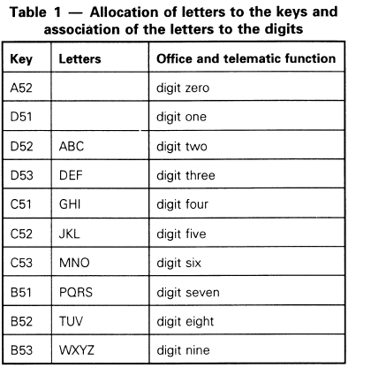

Annex A
(informative)
Bibliography

[I] IS0 9564~1:1991, Banking Personal Identification Number management and security Part 1: PIN protection principles and techniques.
[2] ITU-TS Recommendation E. 161 Arrangement of figures, letters and symbols on telephones and other devices that can be used for gaining access to a telephone network.
[3] IEC 948 Numeric keyboard for home electronic systems (HES).

